
Aeroklub Krainy Jezior
Ul. Olsztyńska 15A 11-500 Giżycko
tel./fax. (087) 428 42 93, tel.(089) 752 45 21, 752 30 31 , www.lotniskoketrzyn.pl

Mazury AirShow 2013
3-4 August 2013, Giżycko

3 August 2013 (Amphitheatre and Niegocin’s beach)

10.00-19.00 | - Opened Mazury Residence Day near Giżycko,.  - Opened Wilamowo Airport Day, planes exposition, parachuting;  - Information about National Reserve Forces.– Wilamowo/Giżycko;
10.30-12.00 | - Inauguration of Mazury AirShow 2013 (Amphitheatre);  - Performance by jazz band "Small Band”;
 | - Air Forces Orchestra Concert,;
12.00-14.00 | - I Part of the AirShow,
14.00-16.00 | - Premmy-introducing fly as a part of Mazury Nature’s Miracle (from Wilamowo),  - Demonstration the Water Volunteer Rescue Service with the participation the police helicopter;
16.00-18.00 | - II Part of the AirShow;
18.00-19.00 | - Premmy-introducing fly as a part of Mazury Nature’s Miracle (from Wilamowo),
20.00-22.00 | - “Ship-part” -inauguration meeting of aviation-VIP-only planes crew/invited people party;
22.00-22.10 | - Fireworks Show (beach).

4 August 2013 (same place)

10.00-18.00 | - Opened Mazury Residence Day near Giżycko  - Opened Wilamowo Airport Day, planes exposition, parachuting;  - Information about National Reserve Forces.– Wilamowo/Giżycko;
10.00-12.00 | - Premmy-introducing fly as a part of Mazury Nature’s Miracle (from Wilamowo),
11.00-14.00 | - III Final Part of the AirShow;
14.00-14.30 | - Air Forces Orchestra Concert,;
14.30-15.00 | - Grand Final of the Mazury AirShow 2013 and The Friends of Aviation and Masuria International Fly-In (amphitheatre)
15.00-20.00 | - Premmy-introducing fly as a part of Mazury Nature’s Miracle (from Wilamowo),

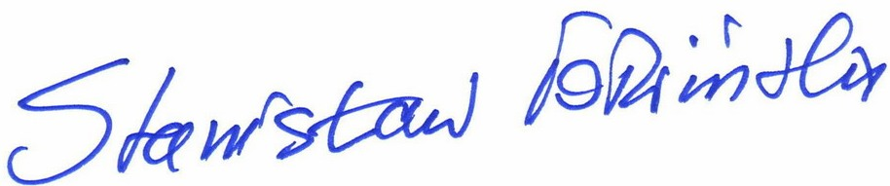

Stanisław Tołwiński
President of AKJ

Mazury,10.01.2013

